

Name: **Rodeeyah**

Surname: **Hemra**

Class: **4** No: **1**

**Bankohyaratodnui school**

Satun Primary Educational Service Area Office

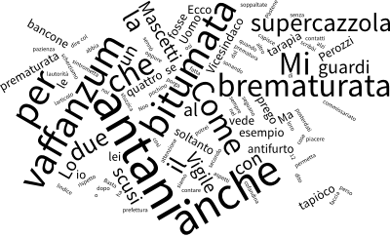

**Book**

**VOCABULARY**