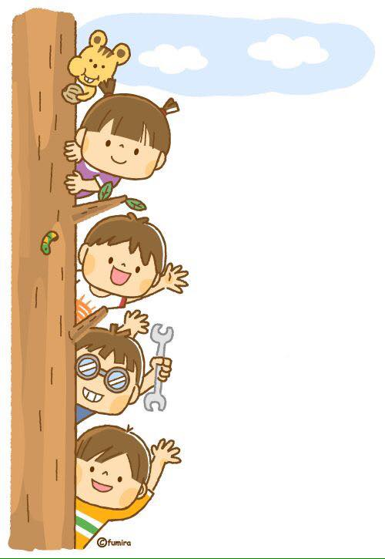

**READ**

**WRITE**

**& REVIEW**

Name.......................................

Class.............................

No..................

**Bankohyaw School**

**Satun Primary Educational**

**Service Area Office**

**Vocabulary**